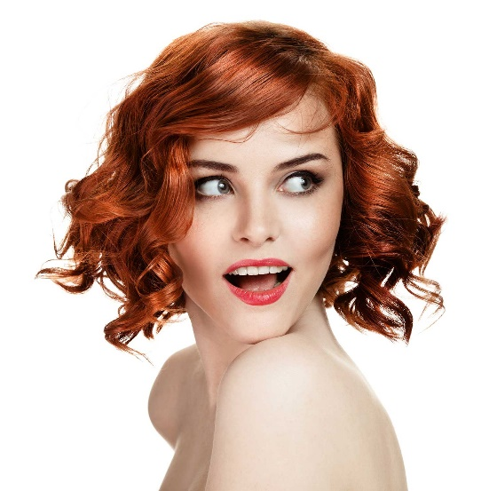
ALL NEW! NATURAL MAKEUP
Pamper yourself with naturally derived, vegan, gluten- and cruelty-free mineral makeup. No synthetics, fillers, or additives. Try for yourself and discover the difference.

Foundation Lip Gloss
Eyeshadow Bronzer
Misting Spray Mascara
Blush Multitasker
Lipstick Veil
Eyeliner Hydrating Primer
Mattifying Primer Luminous Cleansing Oil
Lustrous Hair Oil

GET STARTED NOW

